Title of the manuscript’s Asian Health, Science and Technology Reports
First Author¹, Second Author², …… and Last Author¹*

¹Department, Faculty, University, City, State/Province (if any), Postcode, Country
²Department, Faculty, University, City, State/Province (if any), Postcode, Country
^{x}Department, Faculty, University, City, State/Province (if any), Postcode, Country
* Corresponding author. E-mail address: xxxxxx@xxxx.xx.xx
Received: xx Xxxxxxxx 20xx; Revised: xx Xxxxxxxx 20xx; Accepted: xx Xxxxxxxx 20xx; Available online: xx Xxxxxxxx 20xx

Abstract
The abstract should summarize the content of the paper. The maximum number of words in the Abstract is 350 and must be written in a single paragraph. Do not have references or displayed equations in the abstract. The manuscript you prepare, and submit as a Word document, should be fully and correctly formatted. You must spell check and grammar check (F7). All text must be formatted by Style. If you don’t understand about Styles, view the videos on the Graduate School website. The document format includes: Paper Size = A4, Orientation = Portrait, Margins = Top 2.5cm, Bottom = 2.5 cm, left = 3 cm, right = 2.5 cm, apply to whole document.

Keywords: journal format, printing, references (not more than 5 words)

Introduction

All the major headings are Heading 1 Style.
This is an example of a Normal paragraph, that is, a usual paragraph that has been stated as Normal Style. The paper should have logical sections, Introduction, Content, Conclusion and Suggestions, Acknowledgements, Author Contributions, Conflict of Interest, Funding and References, in Heading 1 style.

Content

Where sub-headings are used, they should be in Header 2 Style. The standard, or normal, paragraph should be in Normal Style. Where authors have images or pictures that are .jpg format or other graphics format, Authors should format them as Wrap Text, Tight.

Example sub-heading: Inserting a Figure

Text following the Header 2 sub-heading
Where sub-headings are used, they should be in Header 2 Style. The standard, or normal, paragraph should be in Normal Style. As is the case in all of the paper, paragraphs should be in Normal Style. When authors are showing their results in tables, authors should define a new style and call it Table Data Style. Similarly, you should define a Table Figure Label Style. Using these 2 styles sets the formatting of those separately from Normal style. If you do not understand about this, you should view the videos on the Graduate School website.

Example sub-heading: Formatting Tables
Text following the Header 2 sub-heading, which should be in Normal Style.

Table 1 This is a brief label that links the table to your discussion (Example)
Position | Male |  |  | Female |  |  | Total
Position | Left | Right |  | Left | Right |  | No. | (%)
1 | 0 | 0 |  | 1 | 0 |  | 1 | 0.21%
2 | 0 | 0 |  | 0 | 1 |  | 1 | 0.21%
3 | 56 | 49 |  | 138 | 133 |  | 376 | 40.09%
4 | 73 | 78 |  | 156 | 167 |  | 474 | 50.53% *
5 | 24 | 25 |  | 21 | 15 |  | 85 | 8.75%
6 | 0 | 1 |  | 0 | 0 |  | 1 | 0.21%
Total | 153 | 153 |  | 316 | 316 |  | 938 | 100%
* p < 0.05

Here authors can enter any narrative or further information allowing the table to be fully understandable. But this is not the place for a full analysis and discussion of the data. That is done in the main text of the Results Section.
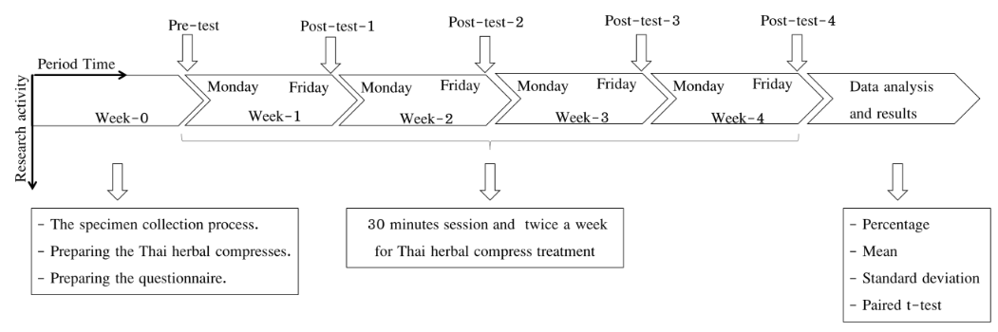

Figure 1 This is a brief label that links the table to your discussion (Example)

Conclusion and Suggestions

In this section there may be sub-sections, with sub-section headings. These should be styled as Heading 2 style.

Acknowledgments

In this section authors include all of the acknowledgments as guided in the guidelines and publication ethics. Funding is not included in this section and this section could be omitted in case of no acknowledgements.

Author Contributions

In this section, authors are required to specify each contributor's role in the manuscript using the Contributor Roles Taxonomy (CRediT). The designated roles encompass a range of responsibilities such as Conceptualization, Methodology, Investigation, Data Curation, Formal Analysis, and Writing—Original Draft. For a comprehensive list of all defined roles, please refer to the official CRediT website (https://credit.niso.org/)
Author 1: contribution….
Author 2: contribution….
Author 3: contribution….

Conflict of Interests

All authors declare that they have no conflicts of interest. (Amend this declaration statement in case authors have any potential conflict of interest)

Funding

The funding information, names of funding agency/organization and grant numbers (if any), will be included in this section. Otherwise, authors may indicate that the authors received no financial support for the research of this article.

Declaration of Generative AI and AI-assisted Technologies

Authors are required to disclose any use of artificial intelligence (AI) tools in the preparation of their manuscript (if any). Please indicate the specific tool or service utilized and the purpose for its use. We recommend the following format for your declaration:
“During the preparation of this manuscript, the author(s) used [Name of tool/service] for [Purpose]. Following its use, the author(s) thoroughly reviewed and edited the content and accept full responsibility for the final version of the publication.”

References

Davidson, R. J. (2019, August 8–11). Well-being is a skill [Conference session]. APA 2019 Convention, Chicago, IL, United States. https://irp-dn.multiscreensite.com/a5ea5d51/files/uploaded/APA2019_ Program_190708.pdf
Fahmy, A., Rabab Zalat, A., & Rabei, A. (2020). In vitro evaluation of the antiparasitic activity of Syzygium aromaticum against adult and larval stages of Trichinella spiralis. Scientia Parasitologica, 21, 94-101. http://www.zooparaz.net/scientia/2020_21_03/SP3-2020-094-101-Fahmy.pdf
Hininger-Favier, I., Benaraba, R., Coves, S., Anderson, R. A., & Roussel, A. M. (2009). Green tea extract decreases oxidative stress and improves insulin sensitivity in an animal model of insulin resistance, the fructose-fed rat. Journal of the American College of Nutrition, 28(4), 355-361. https://doi.org/10.
1080/07315724.2009.10718097
Horvath-Plyman, M. (2018). Social media and the college student journey: An examination of how social media use impacts social capital and affects college choice, access, and transition (Publication No. 10937367). [Doctoral dissertation, New York University]. ProQuest Dissertations and Theses Global
Kaufman, K. A., Glass, C. R., & Pineau, T. R. (2018). Mindful sport performance enhancement: Mental training for athletes and coaches. American Psychological Association. https://doi.org/10.1037/ 0000048-000
Moyers, R. E. (1988). Handbook of Orthodontics (4th ed.). Year book medical.
Pope, J., & Owen, A. D. (2009). Emission trading schemes: Potential revenue effects, compliance costs and overall tax policy issues. Energy Policy, 37, 4595-4603. https://doi.org/10.1016/j.enpol.2009.
06.014
Prayag, I. L., & Ramjee, R. (2009). The impact of Newcastle disease control on smallholder poultry production in Mauritius. In R. G. Alsers, P. B. Spadbrow, & M. P. Young (Eds.), Village chickens, poverty alleviation and the sustainable control of Newcastle disease: Proceedings of an international conference held in Dar es Salaam, Tanzania, 5-7 October 2005 (pp. 132-134). ACT: Australian Centre for International Agricultural Research.
Reynolds, G. (2019, April 9). Different strokes for athletic hearts. The New York Times, D4
Smith, F. W., & Rossit, S. (2018). Identifying and detecting facial expressions of emotion in peripheral vision. PLoS ONE, 13(5), e0197160. https://doi.org/10.1371/journal.pone.0197160
Zeleke, W. A., Hughes, T. L., & Drozda, N. (2020). Home–school collaboration to promote mind–body health. In C. Maykel & M. A. Bray (Eds.), Promoting mind–body health in schools: Interventions for mental health professionals (pp. 11–26). American Psychological Association. https://doi.org/
10.1037/0000157-002
Mannari, C., Sportelli, M., Meesala, H., Okoye, O. F., & Ferrari, A. (2025). End-user requirements modelling: An experience report from digital agriculture. Requirements Engineering: Foundation for Software Quality (pp. 386–392). Springer. https://doi.org/10.1007/978-3-031-88531-0_22
Davidson, R. J. (2019, August 8–11). Well-being is a skill [Conference session]. APA 2019 Convention, Chicago, IL, United States. https://irp-cdn.multiscreensite.com/a5ea5d51/files/uploaded/APA2019_
Program_190708.pdf
Maddox, S., Hurling, J., Stewart, E., & Edwards, A. (2016, March 30-April 2). If mama ain't happy, nobody's happy: The effect of parental depression on mood dysregulation in children [Paper presentation]. Southeastern Psychological Association 62nd Annual Meeting, New Orleans, LA, United States.
Pearson, J. (2018, September 27-30). Fat talk and its effects on state-based body image in women [Poster presentation]. Australian Psychological Society Congress, Sydney, NSW, Australia. http://bit.ly/
2XGSThP

